Dependency Manager
# Source: AI Source: Provided by: [Data Path: Persons Table -> ID Column: 1, Name_En Column: Motasem Essam] -> From: [Chatgpt (GPT‑5 Mini)] on [1/26/2026]
A Dependency Manager is a tool that automatically handles the software libraries (dependencies) your project needs to run, build, or compile properly.

🔧 What Is a Dependency?
# Source: AI Source: Provided by: [Data Path: Persons Table -> ID Column: 1, Name_En Column: Motasem Essam] -> From: [Chatgpt (GPT‑5 Mini)] on [1/26/2026]
A dependency is any external code or library your project relies on.
For example:
- A Python web app may depend on Flask
- A Node.js project may depend on express
- A C++ project may depend on libcurl

📦 What a Dependency Manager Does:
# Source: AI Source: Provided by: [Data Path: Persons Table -> ID Column: 1, Name_En Column: Motasem Essam] -> From: [Chatgpt (GPT‑5 Mini)] on [1/26/2026]
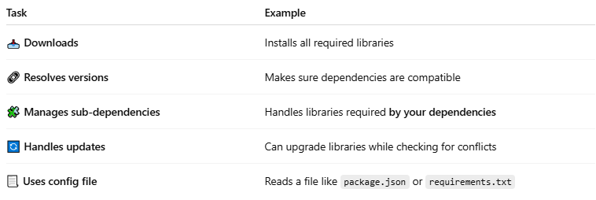

Task | Example
📥 Downloads | Installs all required libraries
🔗 Resolves versions | Makes sure dependencies are compatible
🧩 Manages sub-dependencies | Handles libraries required by your dependencies
🔄 Handles updates | Can upgrade libraries while checking for conflicts
📃 Uses config file | Reads a file like package.json or requirements.txt

🧪 Examples by Language
# Source: AI Source: Provided by: [Data Path: Persons Table -> ID Column: 1, Name_En Column: Motasem Essam] -> From: [Chatgpt (GPT‑5 Mini)] on [1/26/2026]
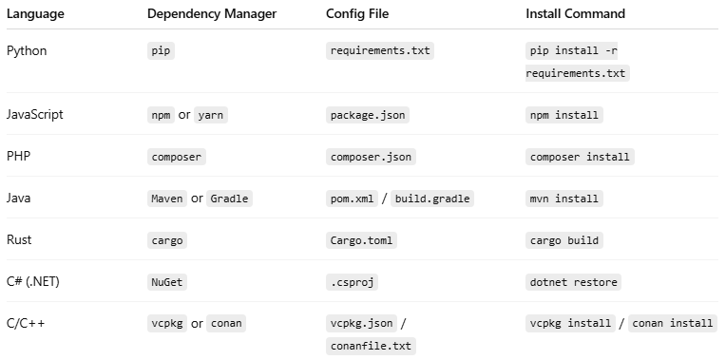

Language | Dependency Manager | Config File | Install Command
Python | pip | requirements.txt | pip install -r requirements.txt
JavaScript | npm or yarn | package.json | npm install
PHP | composer | composer.json | composer install
Java | Maven or Gradle | pom.xml / build.gradle | mvn install
Rust | cargo | Cargo.toml | cargo build
C# (.NET) | NuGet | .csproj | dotnet restore
C/C++ | vcpkg or conan | vcpkg.json / conanfile.txt | vcpkg install / conan install

🧠 Why Use a Dependency Manager?
# Source: AI Source: Provided by: [Data Path: Persons Table -> ID Column: 1, Name_En Column: Motasem Essam] -> From: [Chatgpt (GPT‑5 Mini)] on [1/26/2026]
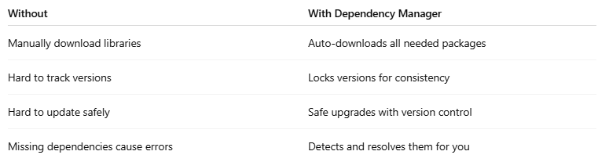

Without | With Dependency Manager
Manually download libraries | Auto-downloads all needed packages
Hard to track versions | Locks versions for consistency
Hard to update safely | Safe upgrades with version control
Missing dependencies cause errors | Detects and resolves them for you

"run," "build," or "compile
# Source: AI Source: Provided by: [Data Path: Persons Table -> ID Column: 1, Name_En Column: Motasem Essam] -> From: [Chatgpt (GPT‑5 Mini)] on [1/26/2026]
Let’s break down what it means for a project to "run," "build," or "compile properly", especially in the context of software development and dependency managers.

⚙️ 1. Run Properly
# Source: AI Source: Provided by: [Data Path: Persons Table -> ID Column: 1, Name_En Column: Motasem Essam] -> From: [Chatgpt (GPT‑5 Mini)] on [1/26/2026]
- "Run" means the program starts and works correctly.
- This is what happens when you execute or launch the app.
✅ Example:
- A Python app using Flask won't run unless Flask is installed.
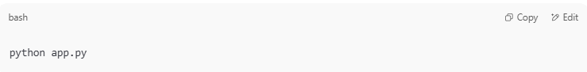
python app.py

If Flask is missing, you'll get an error like:
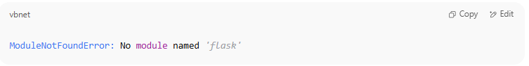
ModuleNotFoundError: No module named 'flask'

🛠️ 2. Build Properly
# Source: AI Source: Provided by: [Data Path: Persons Table -> ID Column: 1, Name_En Column: Motasem Essam] -> From: [Chatgpt (GPT‑5 Mini)] on [1/26/2026]
- "Build" means the project is prepared for running — especially for web apps or compiled apps.
- This might involve:
  - Combining files (HTML/CSS/JS)
  - Optimizing images or code
  - Resolving dependencies
  - Outputting to a build/ folder
✅ Example:
- A React web app needs to build before it's deployed:
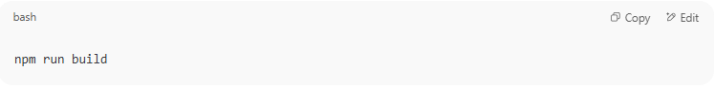
npm run build

This command processes all your source code into a final version for the browser.

🧱 3. Compile Properly
# Source: AI Source: Provided by: [Data Path: Persons Table -> ID Column: 1, Name_En Column: Motasem Essam] -> From: [Chatgpt (GPT‑5 Mini)] on [1/26/2026]
- "Compile" means the source code (like C, C++, Java) is translated into executable code (binary/machine code).
- Compilation fails if:
  - Code has syntax errors
  - A required library is missing

✅ Example:
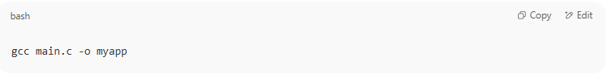
gcc main.c -o myapp

If a needed .h file or library is missing, you’ll get a compile-time error.

🧠 Summary Table:
# Source: AI Source: Provided by: [Data Path: Persons Table -> ID Column: 1, Name_En Column: Motasem Essam] -> From: [Chatgpt (GPT‑5 Mini)] on [1/26/2026]
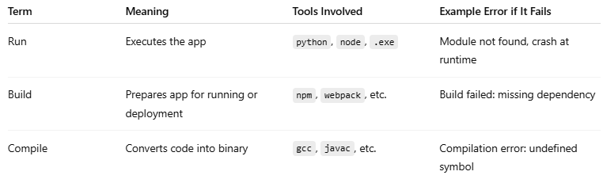

Term | Meaning | Tools Involved | Example Error if It Fails
Run | Executes the app | python, node, .exe | Module not found, crash at runtime
Build | Prepares app for running or deployment | npm, webpack, etc. | Build failed: missing dependency
Compile | Converts code into binary | gcc, javac, etc. | Compilation error: undefined symbol

🔗 Connection to Dependency Managers:
# Source: AI Source: Provided by: [Data Path: Persons Table -> ID Column: 1, Name_En Column: Motasem Essam] -> From: [Chatgpt (GPT‑5 Mini)] on [1/26/2026]
Dependency managers help ensure all needed code (dependencies) are in place so the app can run, build, or compile without errors.

Let me know if you want to see how this works in a specific language like Python or JavaScript!

📦 Package Manager vs Dependency Manager
# Source: AI Source: Provided by: [Data Path: Persons Table -> ID Column: 1, Name_En Column: Motasem Essam] -> From: [Chatgpt (GPT‑5 Mini)] on [1/26/2026]
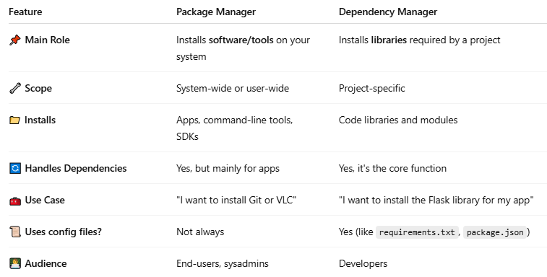

Feature | Package Manager | Dependency Manager
📌 Main Role | Installs software/tools on your system | Installs libraries required by a project
🔧 Scope | System-wide or user-wide | Project-specific
📁 Installs | Apps, command-line tools, SDKs | Code libraries and modules
🔄 Handles Dependencies | Yes, but mainly for apps | Yes, it's the core function
🧰 Use Case | "I want to install Git or VLC" | "I want to install the Flask library for my app"
📜 Uses config files? | Not always | Yes (like requirements.txt, package.json)
👨‍💻 Audience | End-users, sysadmins | Developers

🔧 Examples of Package Managers:
# Source: AI Source: Provided by: [Data Path: Persons Table -> ID Column: 1, Name_En Column: Motasem Essam] -> From: [Chatgpt (GPT‑5 Mini)] on [1/26/2026]
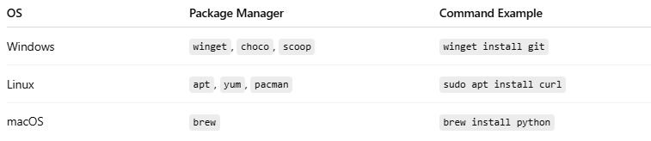

OS | Package Manager | Command Example
Windows | winget, choco, scoop | winget install git
Linux | apt, yum, pacman | sudo apt install curl
macOS | brew | brew install python

🧱 Examples of Dependency Managers:
# Source: AI Source: Provided by: [Data Path: Persons Table -> ID Column: 1, Name_En Column: Motasem Essam] -> From: [Chatgpt (GPT‑5 Mini)] on [1/26/2026]
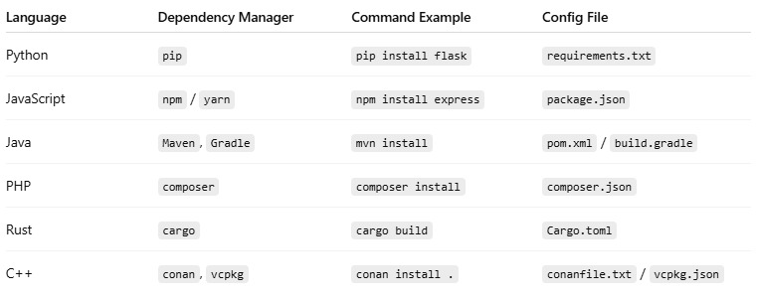

Language | Dependency Manager | Command Example | Config File
Python | pip | pip install flask | requirements.txt
JavaScript | npm / yarn | npm install express | package.json
Java | Maven, Gradle | mvn install | pom.xml / build.gradle
PHP | composer | composer install | composer.json
Rust | cargo | cargo build | Cargo.toml
C++ | conan, vcpkg | conan install . | conanfile.txt / vcpkg.json

🧠 Key Difference:
# Source: AI Source: Provided by: [Data Path: Persons Table -> ID Column: 1, Name_En Column: Motasem Essam] -> From: [Chatgpt (GPT‑5 Mini)] on [1/26/2026]
- Package managers: Focus on software/tools for your system.
- Dependency managers: Focus on libraries/code your project needs to run or compile.

📌 In Summary:
# Source: AI Source: Provided by: [Data Path: Persons Table -> ID Column: 1, Name_En Column: Motasem Essam] -> From: [Chatgpt (GPT‑5 Mini)] on [1/26/2026]
A dependency manager:
- Keeps your project working
- Saves time and errors
- Makes collaboration and deployment easier

